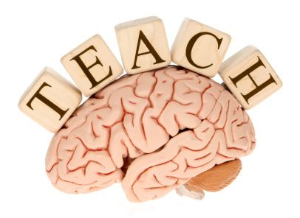
Brain Gym
What? We are excited to offer a new children’s group based on movement and relaxation!!
Who? The movements are beneficial for persons of all ages, and abilities.
This group will focus on children in 2nd through 5th grade!
When? Tuesday’s 5:30 pm- 6pm (30 minutes per week)
Please call HOME for current dates.
Where? House of Mercy and Encouragement (H.O.M.E.) Foundation
2030 Main Street, Dunedin (West of the Neighborhood Walmart)
Details? Brain Gym is a movement–based learning play group and is modeled after the work of Paul E. Dennison, Ph.D., and Gail E. Dennison. Brain Gym consists of a series of simple exercises to stimulate brain function and have been designed to encourage the two hemispheres of the brain to work in harmony. These are simple activities that the person does that helps improve learning. Research shows that it improves listening skills, concentration, organization and memory often resulting in higher academic achievement. It also contributes to better self-control in young children and helps teenagers develop self-confidence and social skills. Improvements in communication lead to improved family relationships, with lowered levels of stress.
Cost? For children already enrolled in our Social Skills Group, the cost is $8.00 per ½ hour class. For children not enrolled in our Social Skills Group, the drop in rate is $12.00 each ½ hour session.

