SAVE THE DATE!
2014 HOME Fundraiser
Dinner, Dance, Karaoke & Silent Auction

Saturday, November 22nd
The Dubois Center 6:30-10:00pm
750 San Salvador Drive. Dunedin, FL 34698

For tickets or sponsorship opportunities,
call 727-786-7951
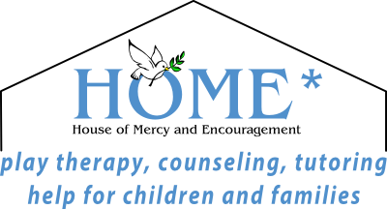
www.houseofmercy-fl.org

